# Exercises: Data Modeling and E/R Diagrams

This document defines the class assignments from the ["Databases" Course @ Software University](https://softuni.bg/trainings/1168/Databases-Jun-2015).

## Create a data model for typical Online Shop System.

We have typical online shop. Every user in the system has username, full name, phone number, website and a shopping basket. The product in the online shop has title, description, price and category. Categories have name. Reviews have content, product and user. Every user have only one shopping basket. Every shopping basket can contain many products. The amount of each product in a basket can vary from 1 to many. Every product can be in many shopping baskets. Every product has many reviews from the users.

### Task 1. Identify the entities and create tables

Your task is to identify the entities for the online shop system. Use the SQL Server Management Studio Designer. Create a new diagram for the database. Create tables for each entity.

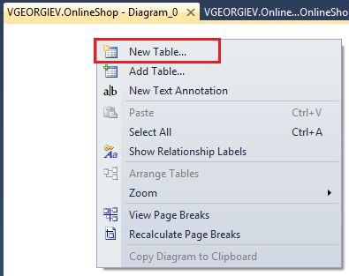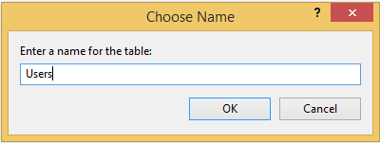

* In the system we should have **Products** and **Categories**. Create tables Products and Categories:

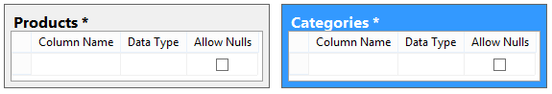

### Task 2. Identity the Columns in the Tables

Your task is to identify the columns for each entity table. Create the columns for the entity tables.

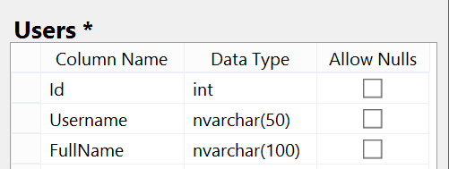

* Products should have id, title, description, price and category. Every table should have primary key (id) required. Title should be nvarchar(50) (Unicode variable string with max length 50) and required. Description should be nvarchar(MAX) and should be optional (Allow Nulls). Price should be money data type and required. We have foreign key column CategoryId with data type money and should be required.

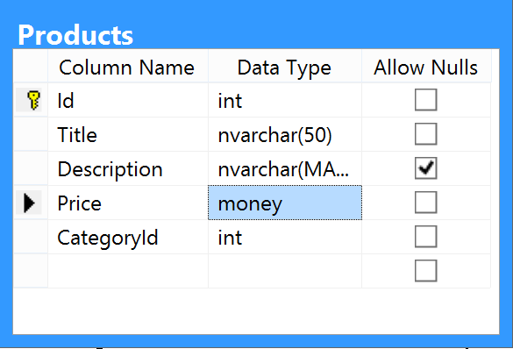

* **Categories** should have **Id** (primary key) with data type **int** and **Name** with data type **nvarchar(50)**.

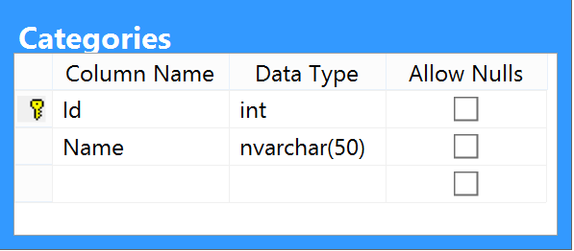

### Task 3. Define a Primary Key for Each entity table

Every tables should have the primary key. Set the primary key for each table.

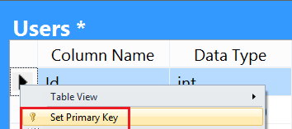

Set the identity specification for all primary keys:

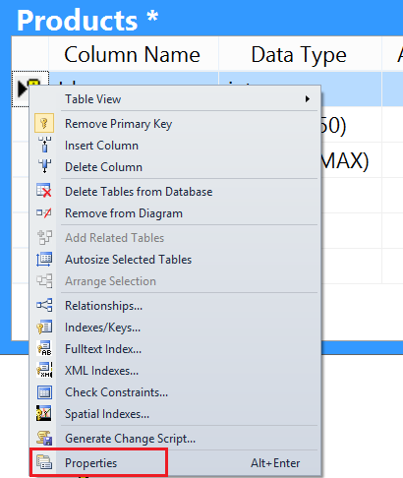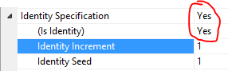

### Task 4. Identify and model the relationships

Your task is to identify the relationships between the tables. You can create the relationship from dragging the foreign key to the other table. If you drag the primary key to the other table, the relationship will be one to one. Many to many relationships requires additional many to many table.



* Make the one-to-many relationship between Products and Categories. Drag the CategoryId to the Categories table. This will create the one-to-many relationship.

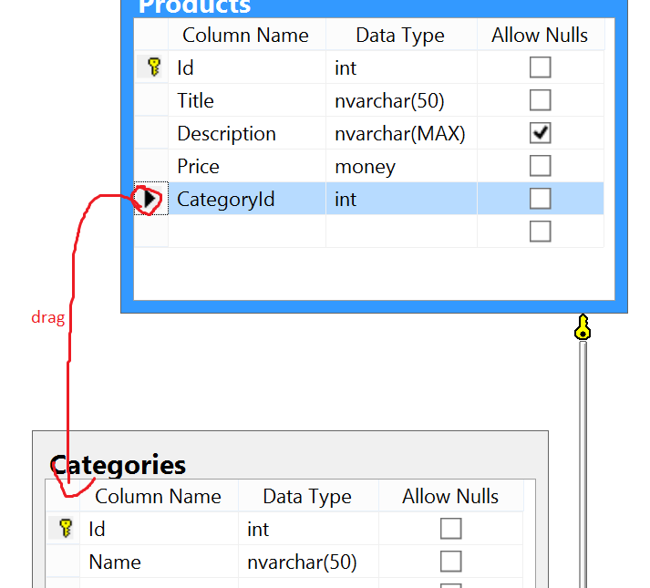

A screen appears for the relationship. You can set the relationship name. FK_Products_Categories is the convention for the relationship. You can choose primary key table and column. Also you can view foreign key table and the foreign key column.

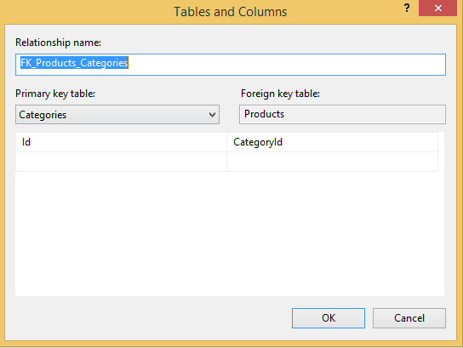

### Task 5. Define the constraints

Your task is to search in google and find how to set the unique constraint to the username of the user and for the category name.

### Task 6. Fill test data in the tables

* First fill the categories.

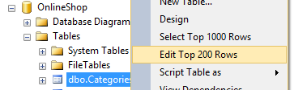

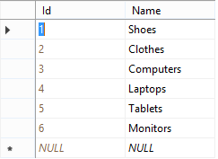

* Then fill the products and for each product you should set the category id.

